S3 Storage classes

1. Standard Frequent

By default, class is standard frequent, here download whenever required on demand, no waiting period.

Costing 1GB----10$

1. Standard infrequent

Infrequent storage class means we required 30 days to download the file, waiting period if we move the file to frequent both the charges will apply in this case.

Costing 1GB---6$

1. Glacier

In this case the time-period will be 90 days, if we want, they will give file but need to pay both amounts

Costing 1GB—4$

1. Deep Glacier

In this case 120 days

Costing 1Gb--- 2$

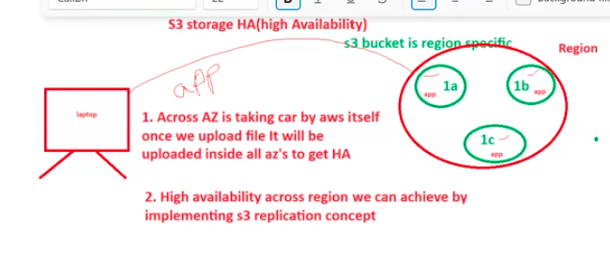

1. Across AZ is taking care by AWS itself once we upload file it will be uploaded inside all AZ’S to get HA
2. High availability across region we can achieve by implementing S3 replication concept.

S3 Query

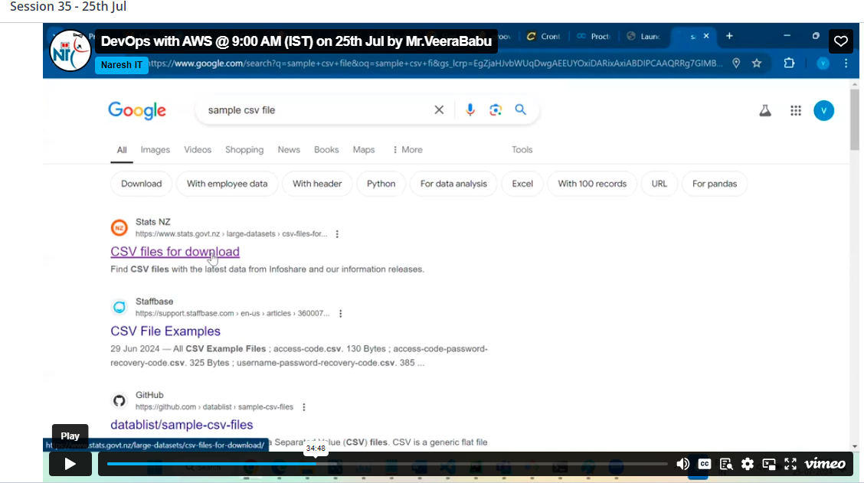

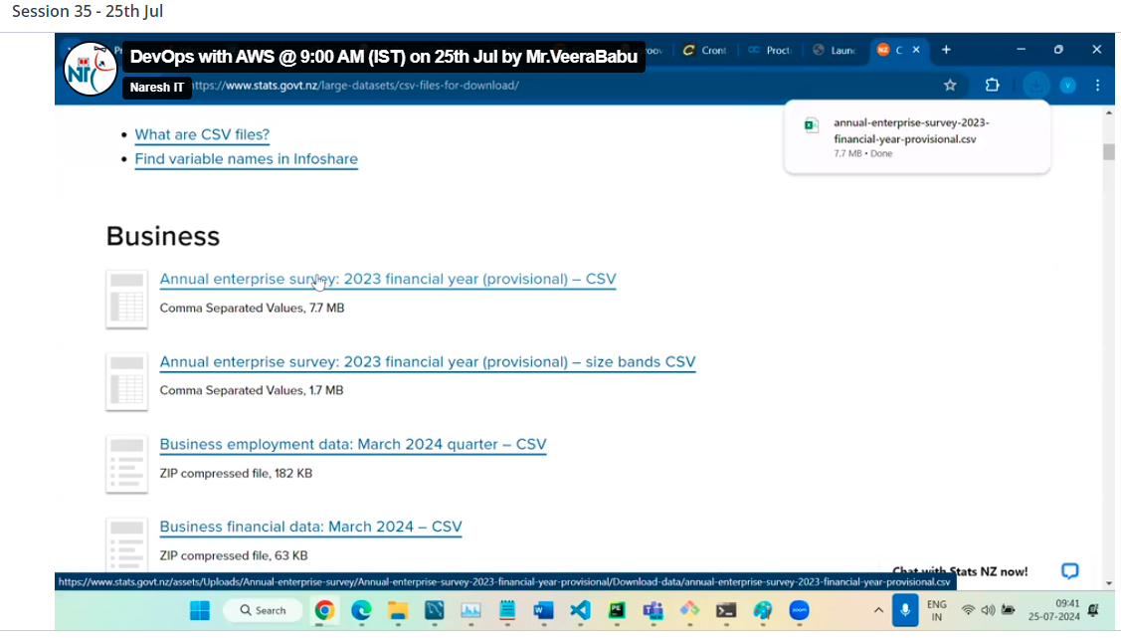

Upload the file

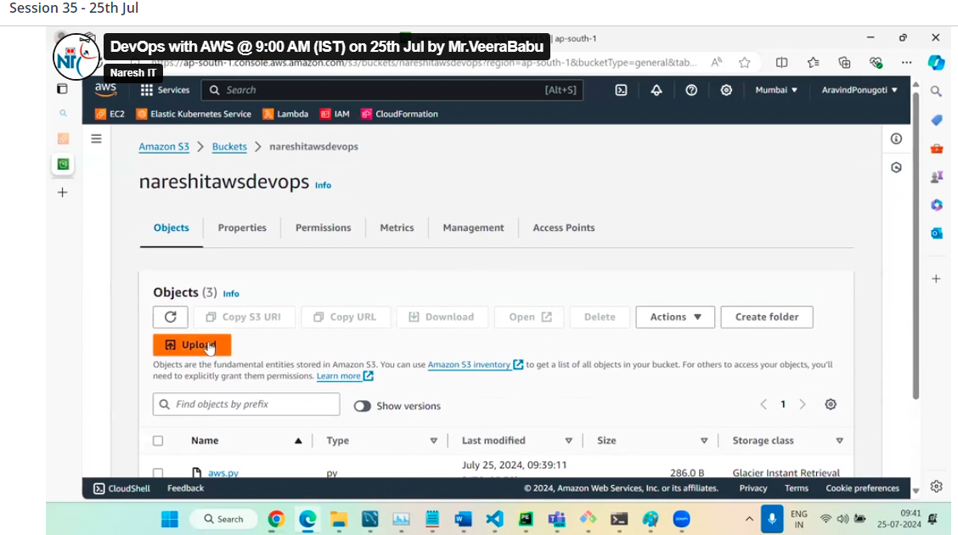

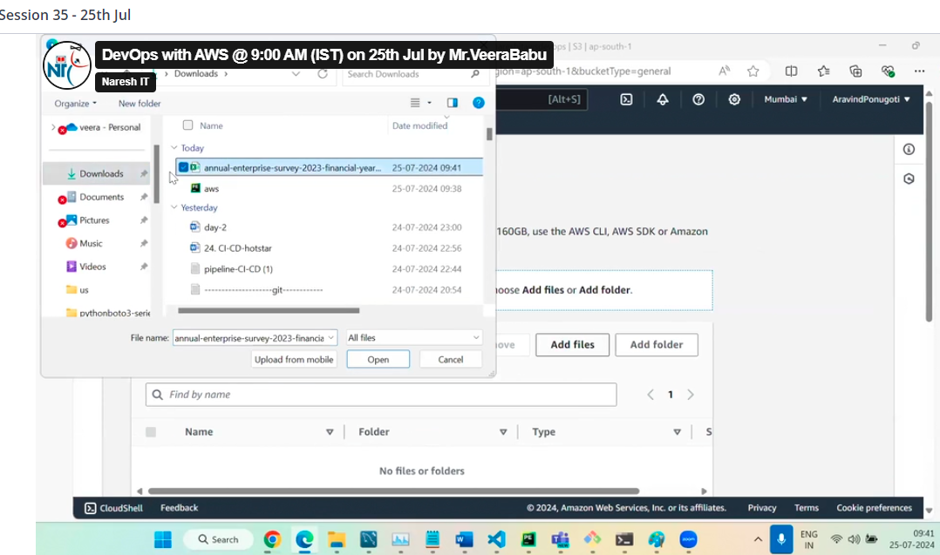

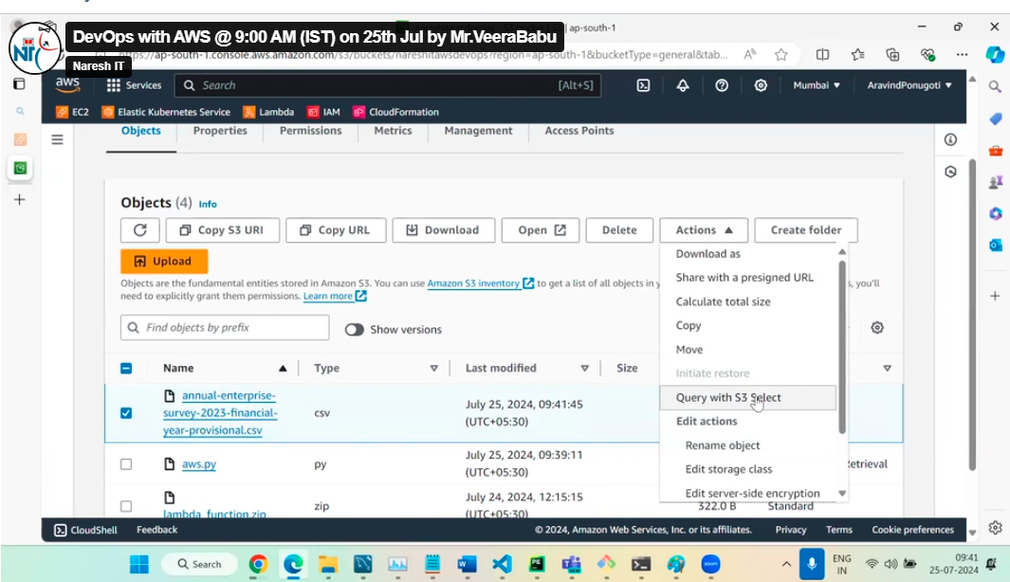

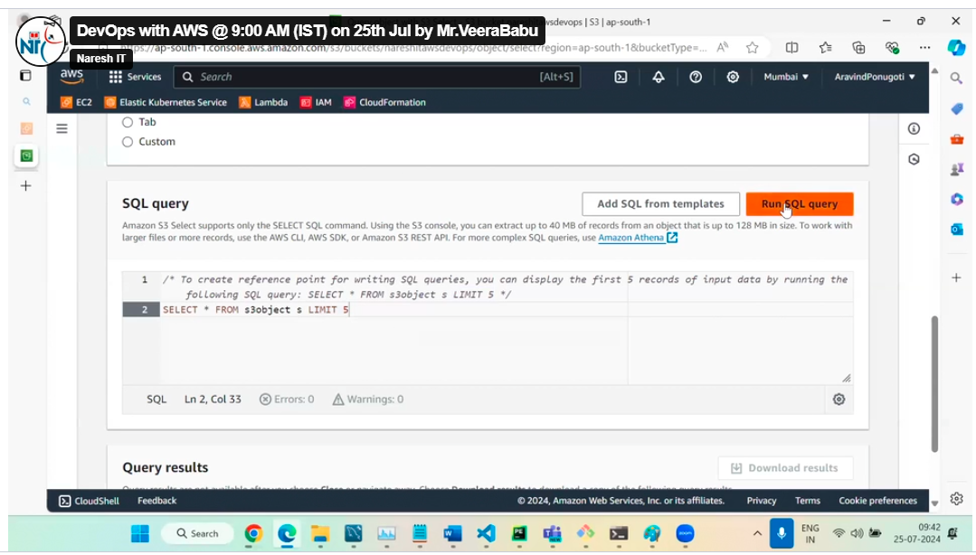

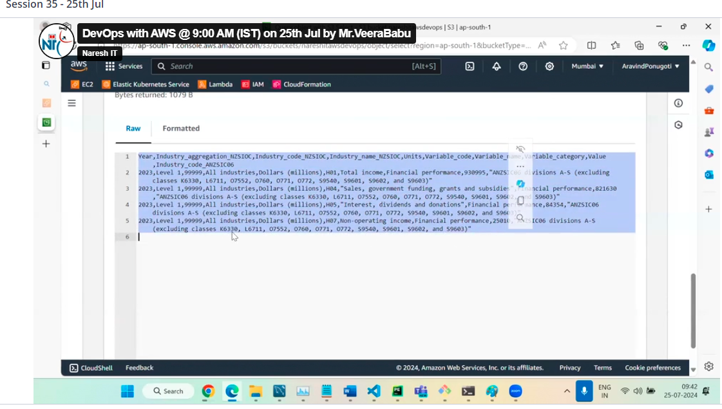

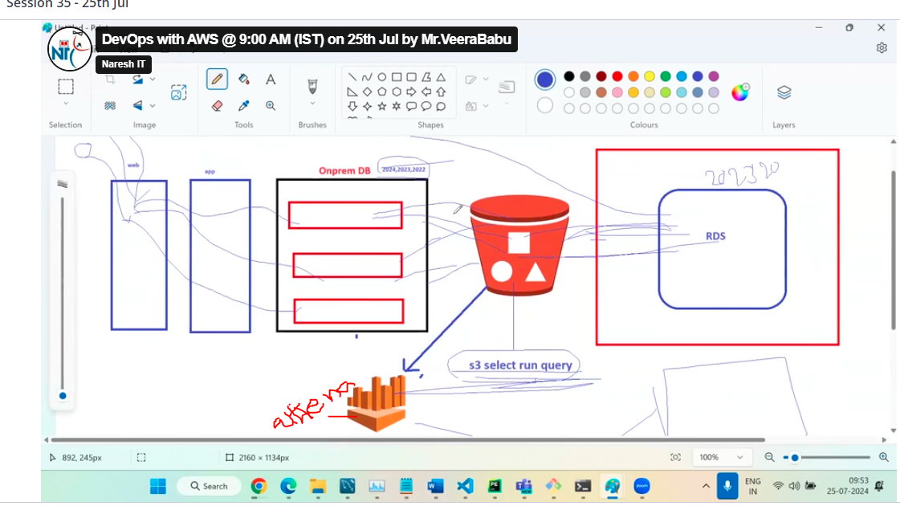

In real time the DB on premises is not directly forwarded to RDS because if any corruption happen loose of data takes place so to avoid this, data can be sent to S3 bucket and configure with Athena tool run the Query, if it passes the data will be moved to RDS

Amazon Athena tool

This tool is only to run the Queries

So S3 bucket is configured to Athena tool and run the queries

S3 bucket is used to run the simple queries

But if we configured Athena tool to S3 we can run complex Queries.

Lifecycle rules

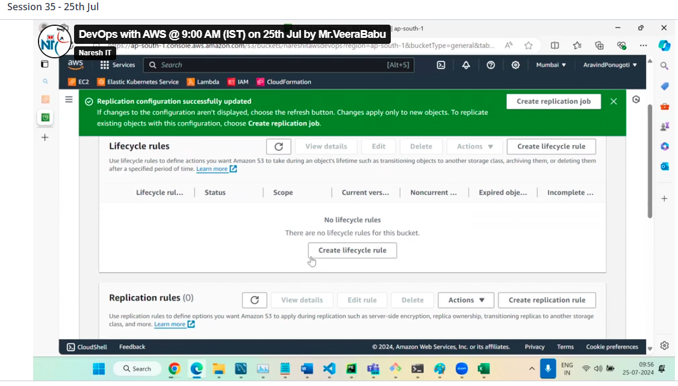

This is used to automate the tasks

If we want to move the file standard frequent to standard infrequent or any other, we can set the rules for example to delete the file after 2 days we can set the rules here

Give any name

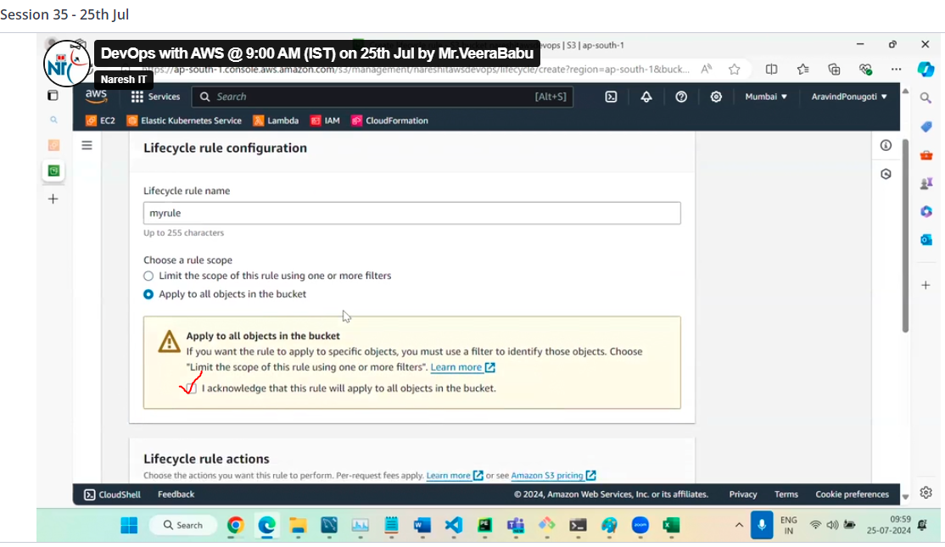

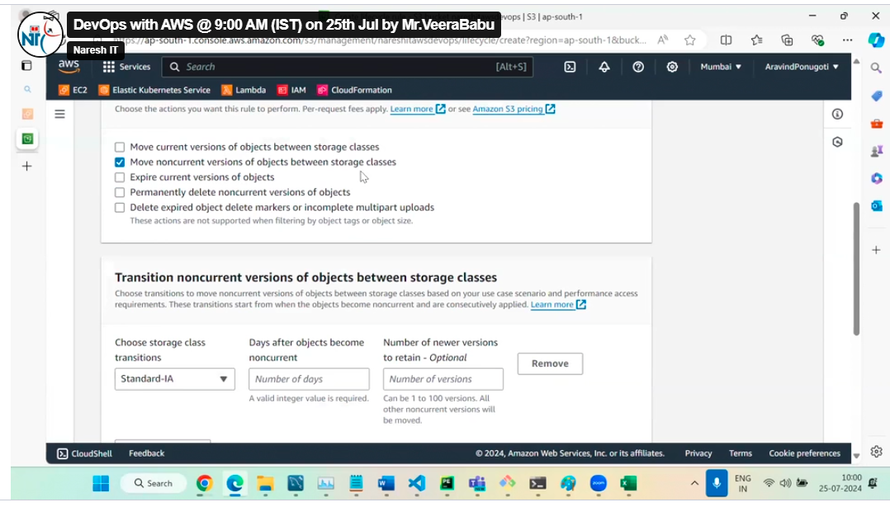

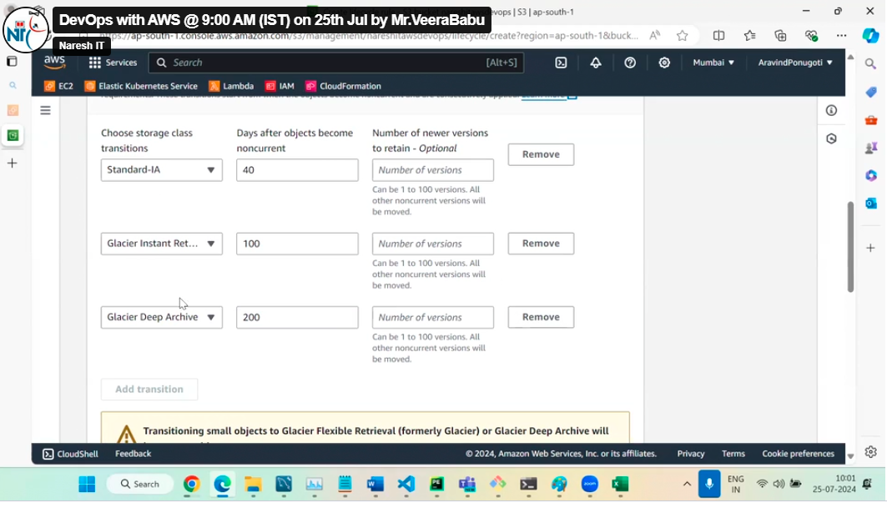

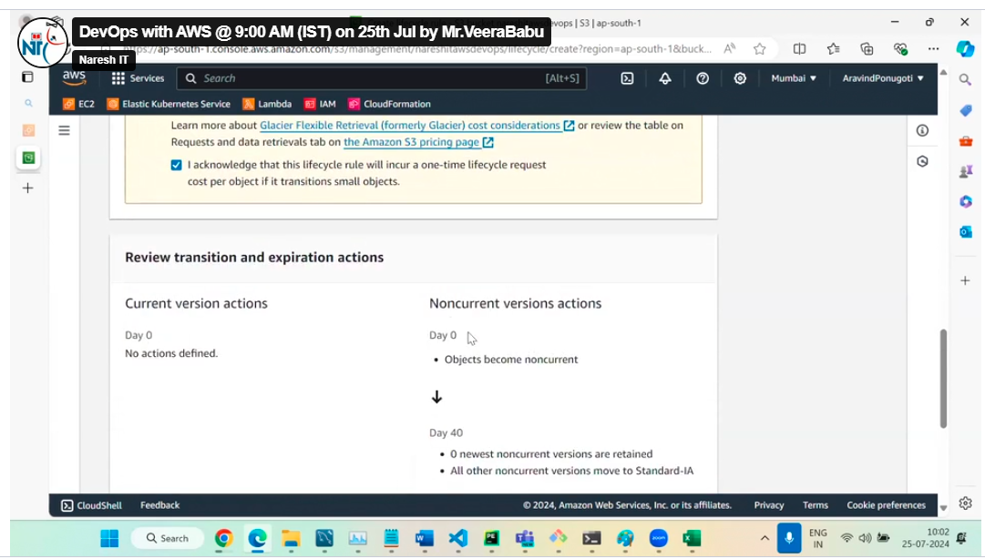

Then click on create rule

Inventory Configurations

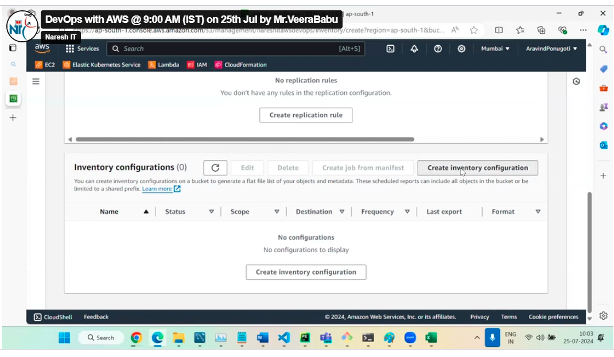

It is nothing but, in this bucket, everything we can track by using inventory operations, when the fill will be uploaded, deleted, when the operation will be started, whatever each and every inventory in your source S3 bucket will store into target S3 bucket.

We can monitor user’s bucket to create my bucket as a target, so well get a reports daily base or weekly base, so from different account we can monitor all the accounts user bucket, will get the reports

Metrics

So, metrics is nothing, but we can just check the bucket size and number of objects only for this

Properties

In properties we have

Static website hosting\*

If any website is running, we can take the HTML configuration files, we can update into S3 bucket.

We can use the S3 URL, they can access website hosting through S3

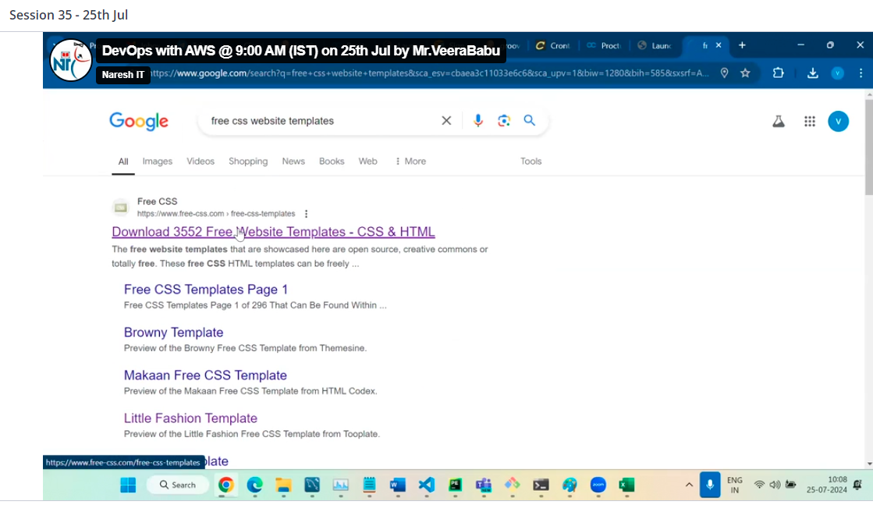

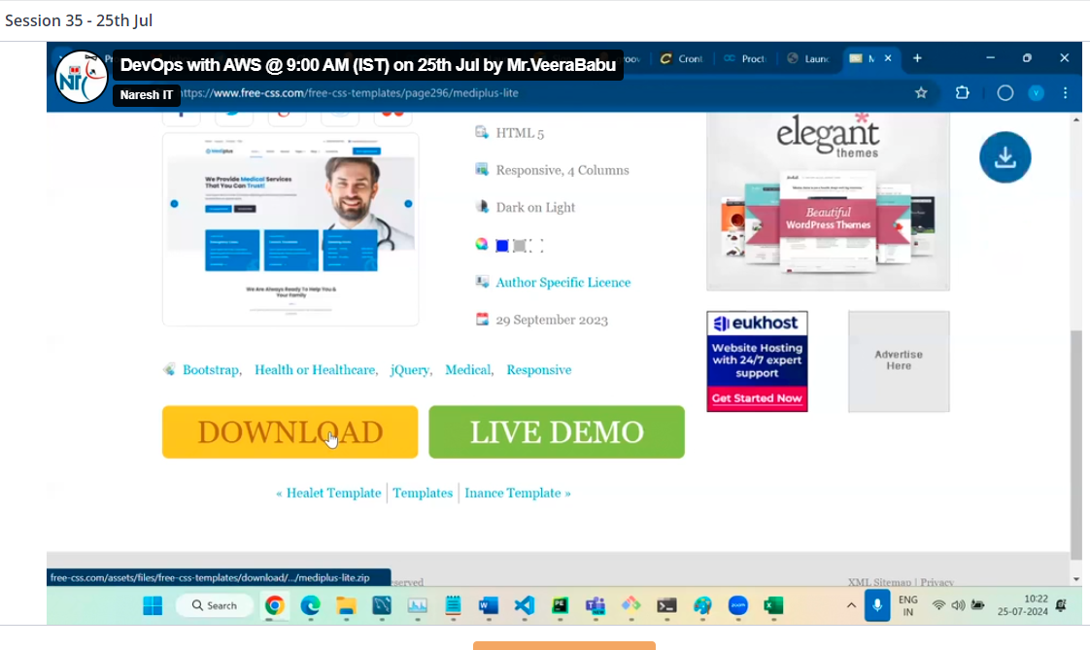

Zip format is downloaded so extract

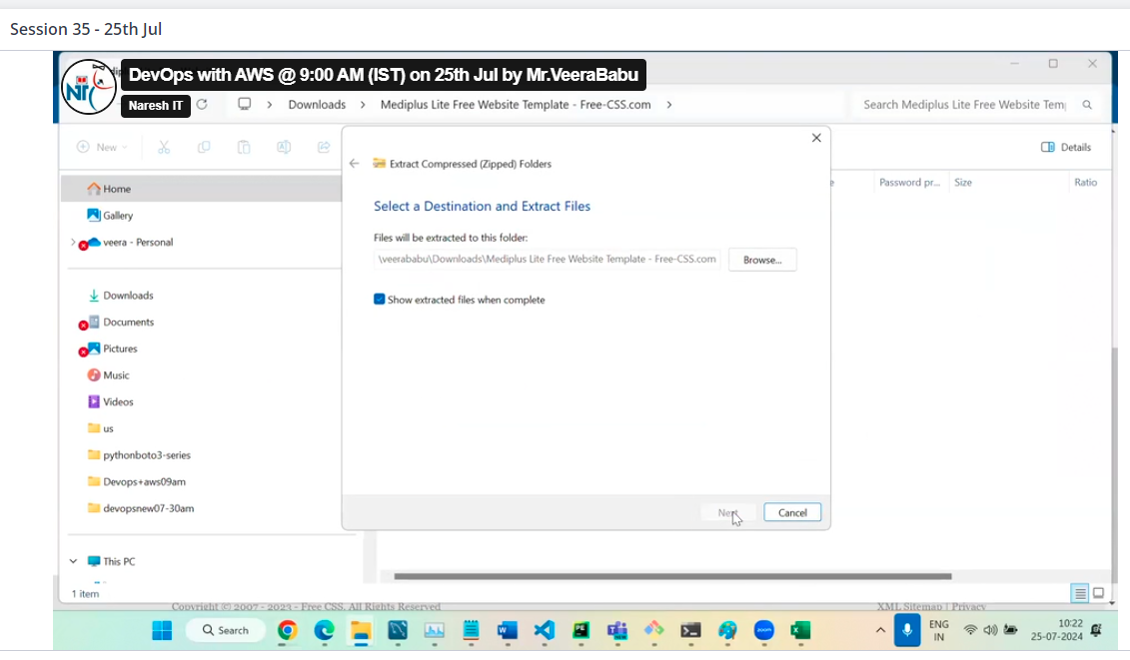

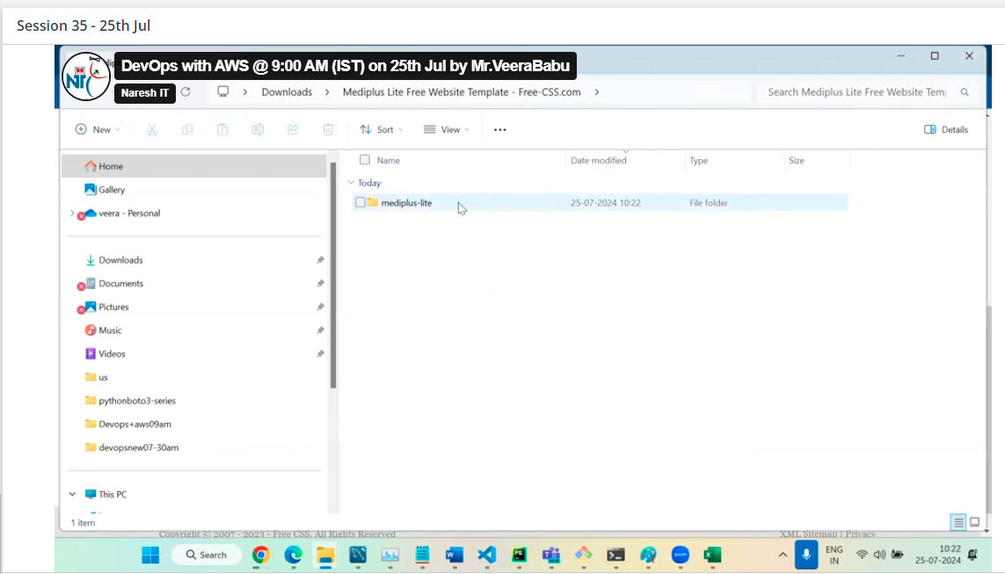

This is my folder

Click on it we will find

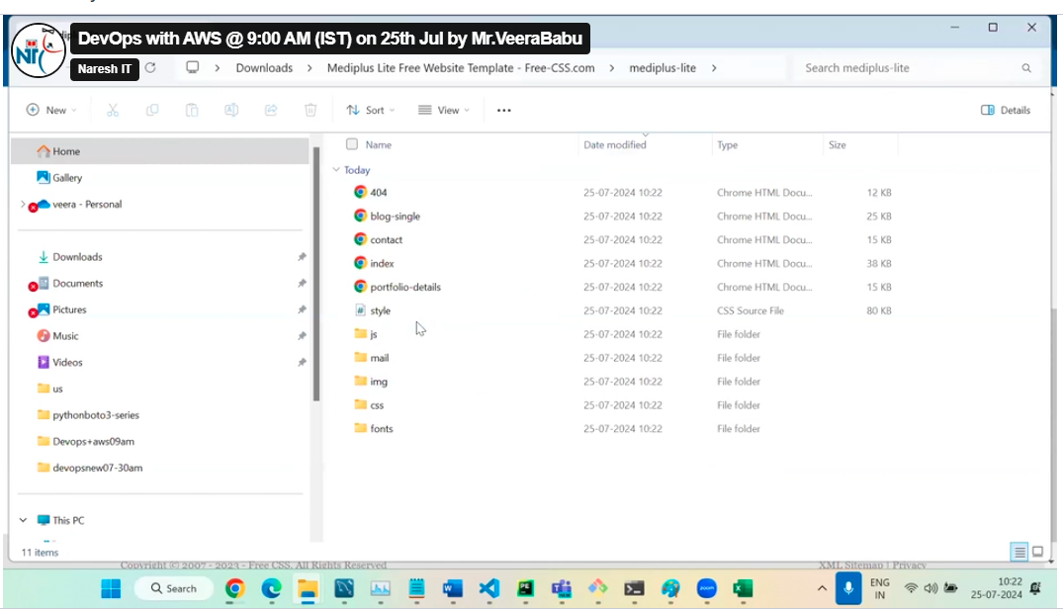

Click on upload

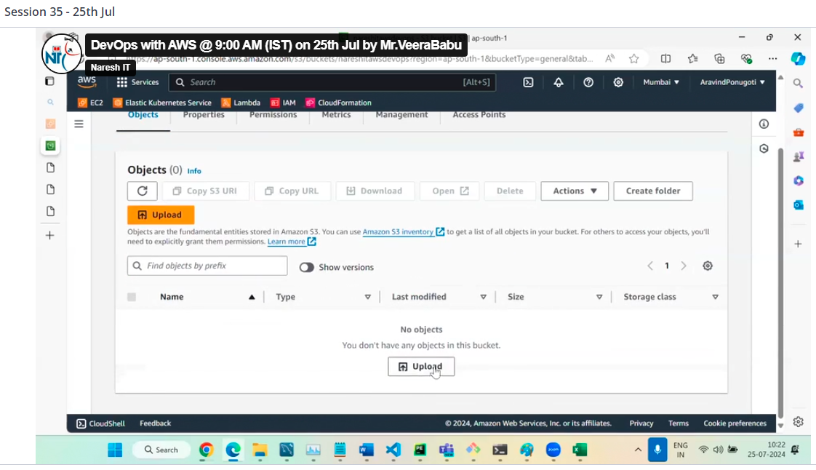

Add file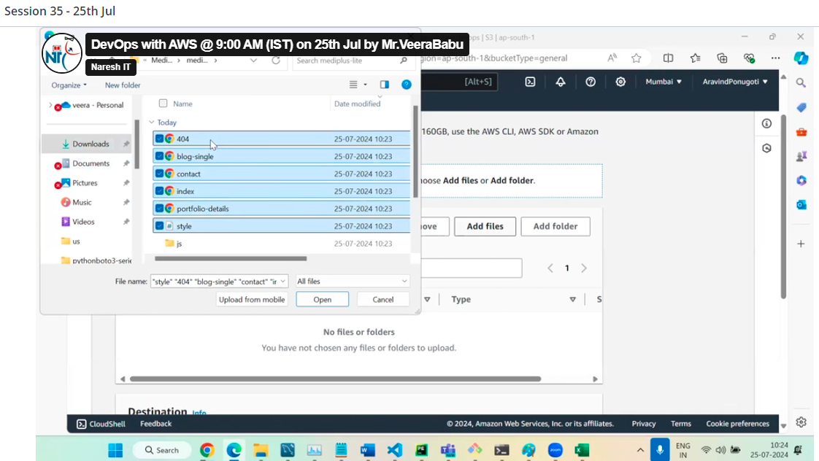

Then click on add folder

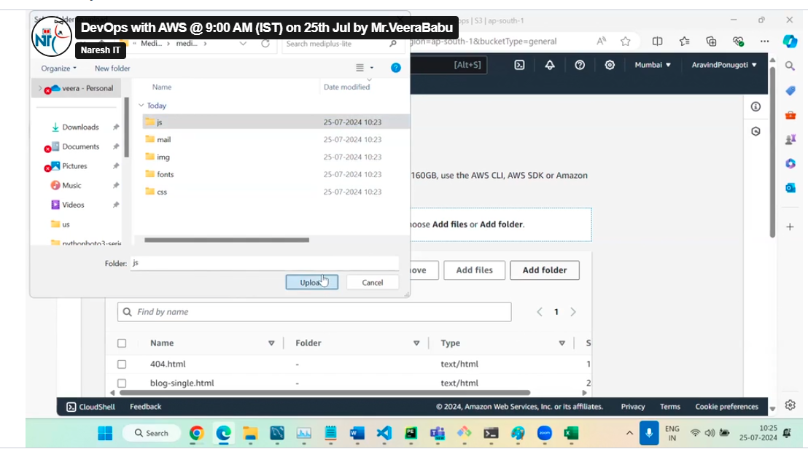

Then by clicking add folders add remaining one by one and click on upload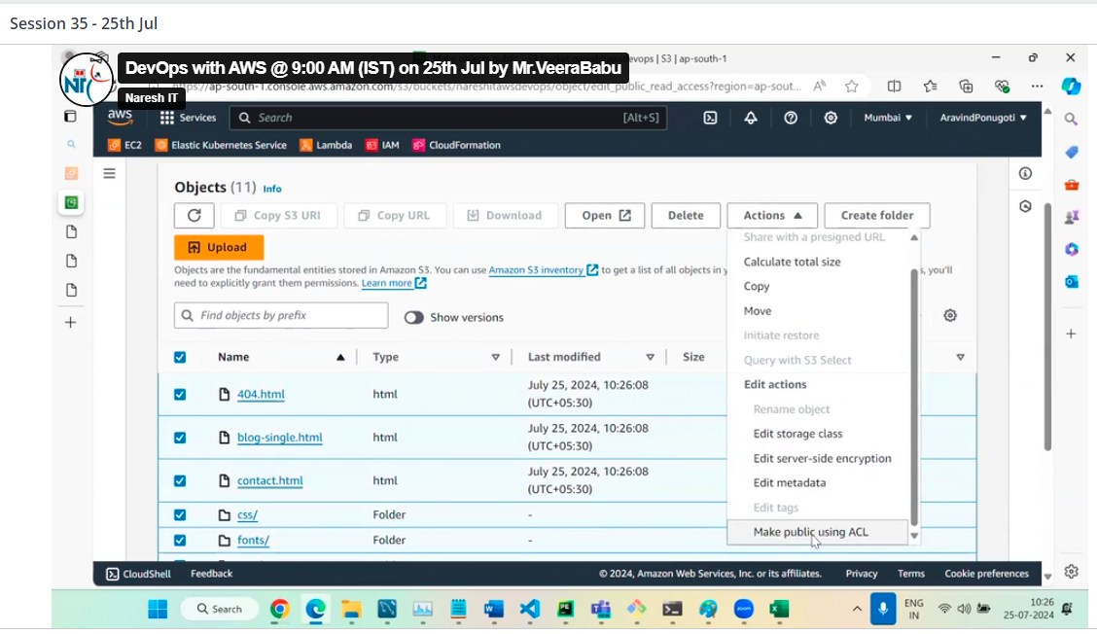

Then click on make public

Properties then go to static website hosting

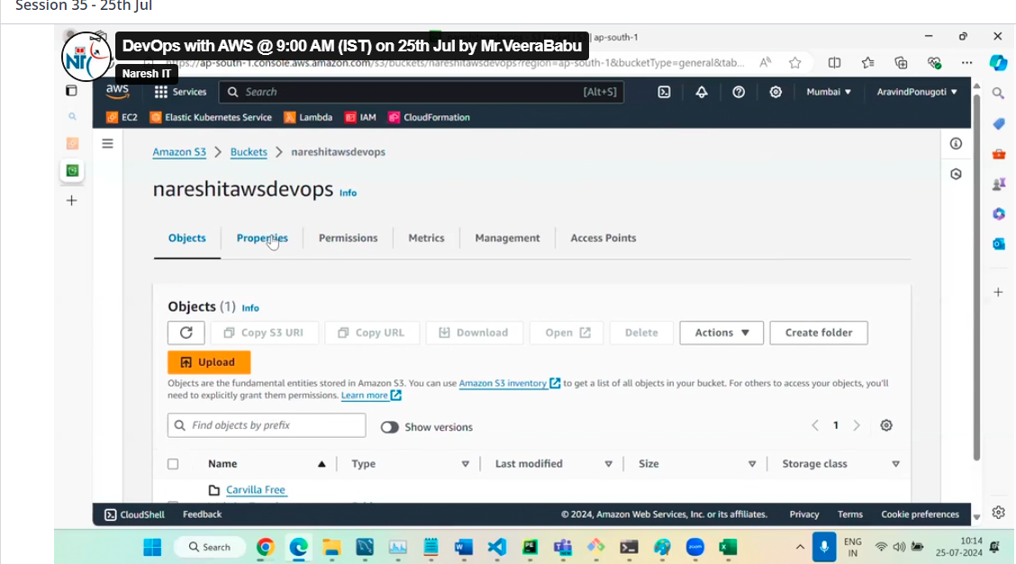

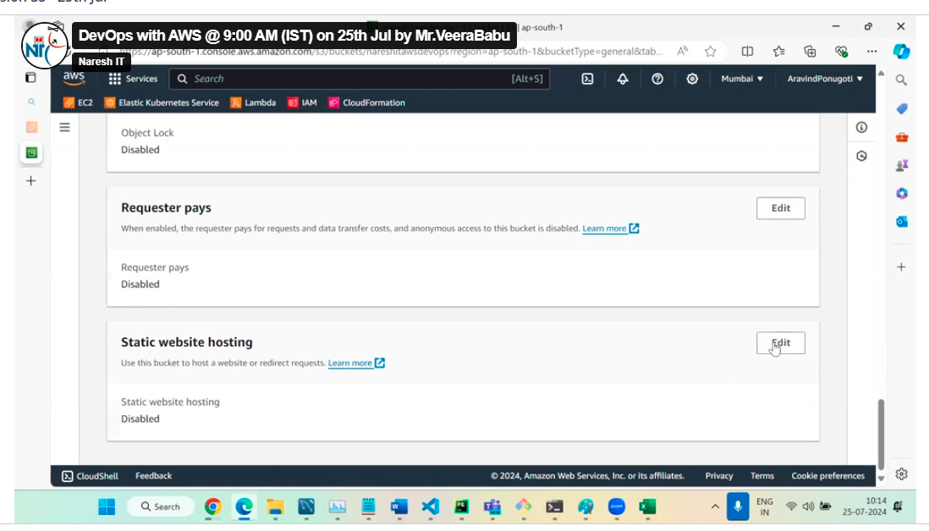

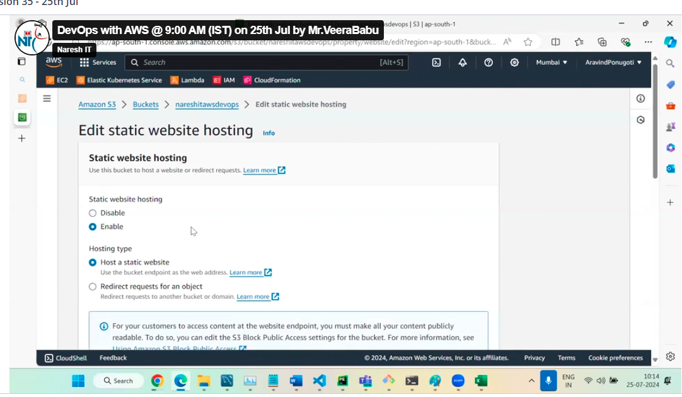

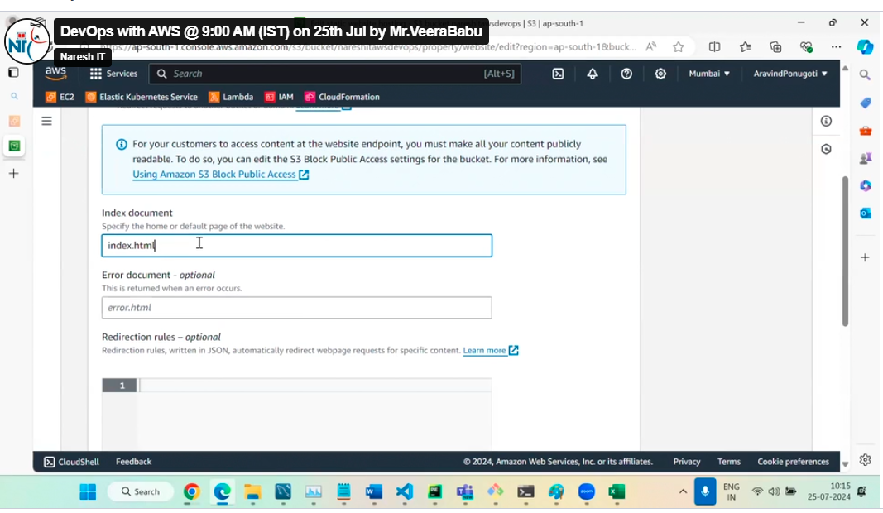

Then click on save the changes

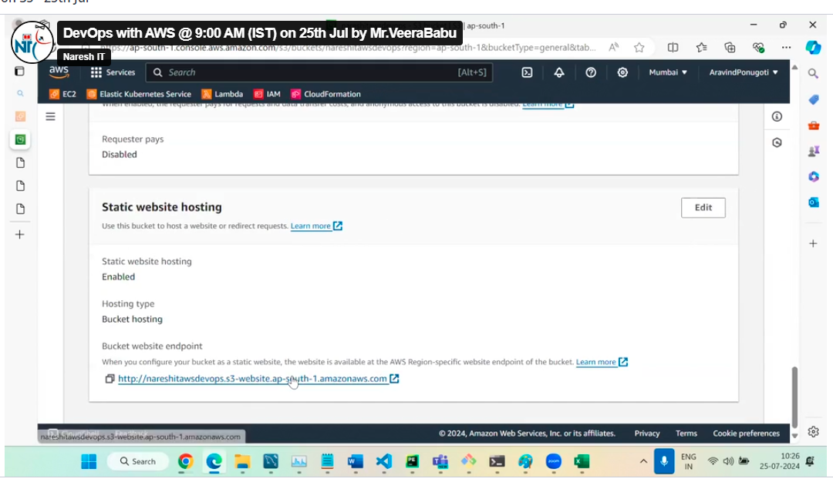

Now click on URL now we can see this

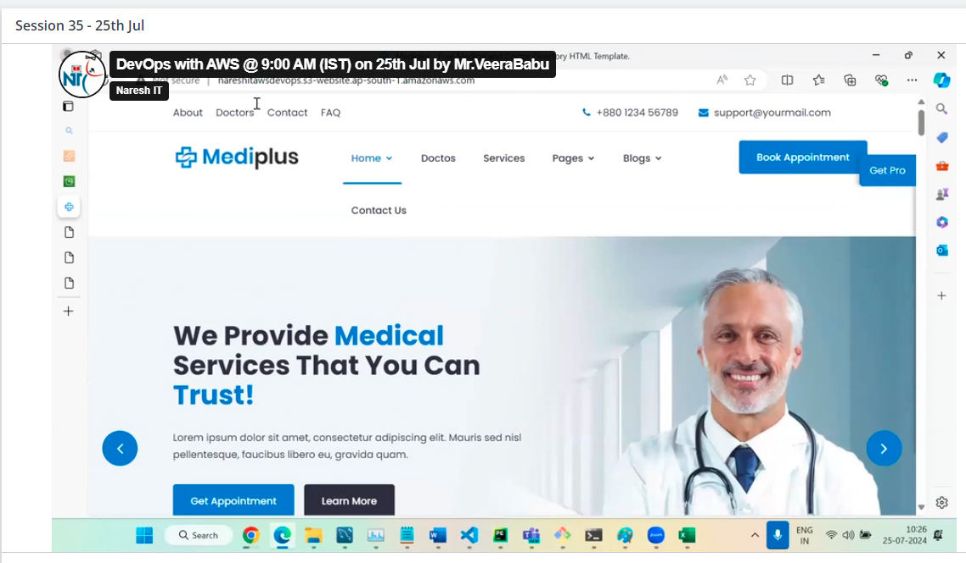

Share with a presigned URL

This is temperaroy acces URL to the public without giving any public access here we can access.

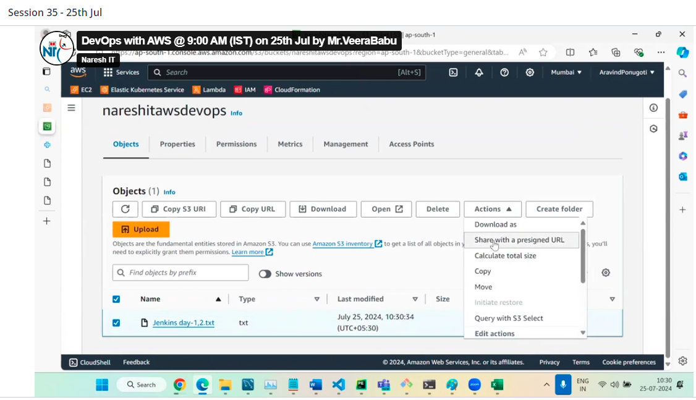

Here we can set the time limit for url access

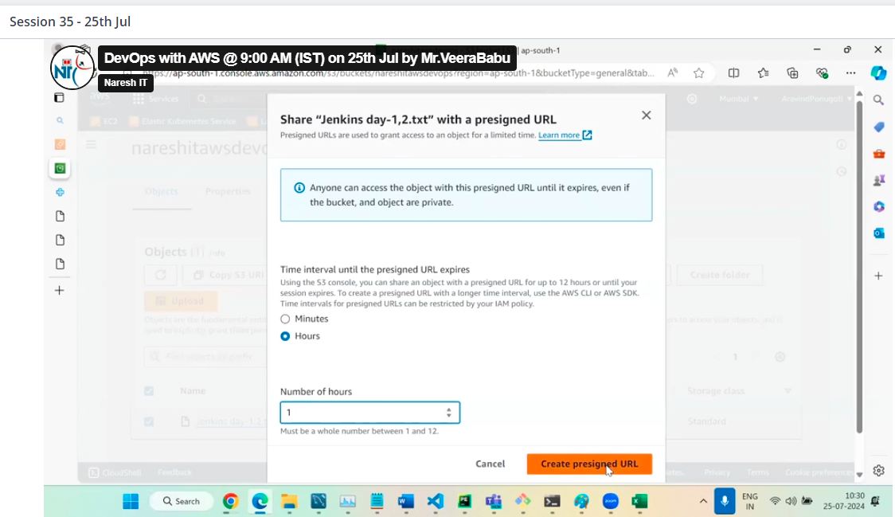

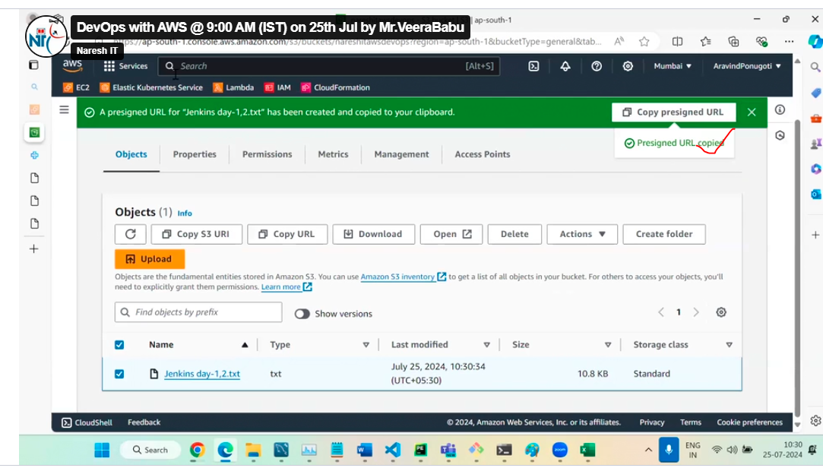

Hit the URL on chrome

